NAME: NAVODITAA A.R
ROLL NO: 241901071

14. LOG ANALYSIS FOR DETECTION AND RESPONSE
DATE: 22/04/2026
Aim:
To understand the fundamentals of log analysis and its role in effective security detection and response.
Procedure:
- Log into TryHackMe and open the Intro to Log Analysis room.
- Study the fundamentals of log analysis and its role in detection and response.
- Understand different log types such as system, network, and application logs.
- Learn best practices for collecting, storing, and analyzing logs.
- Explore essential tools used for monitoring and identifying suspicious activity.
- Complete the tasks and answer the questions in the room.
- Review the summary and confirm completion.
Tasks:
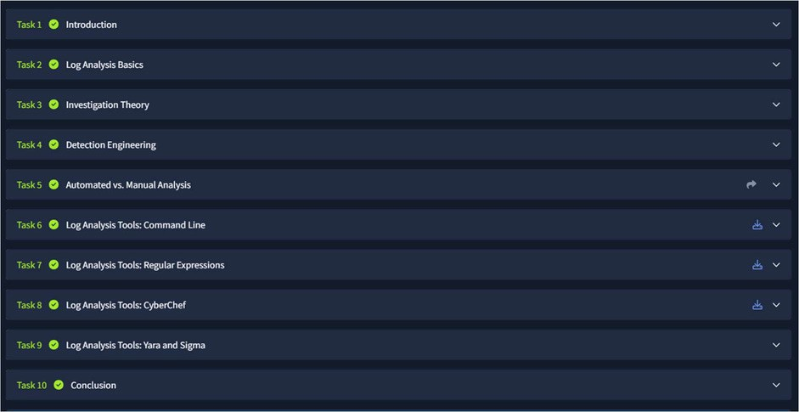
TASK 1 - Introduction

TASK 2 - Log Analysis Basics

TASK 3 - Investigation Theory
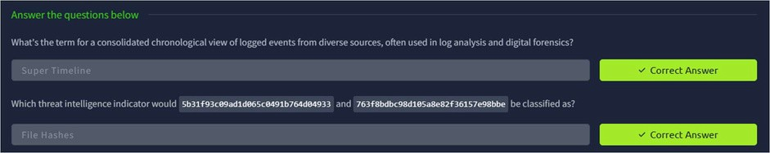
TASK 4 - Detection Engineering
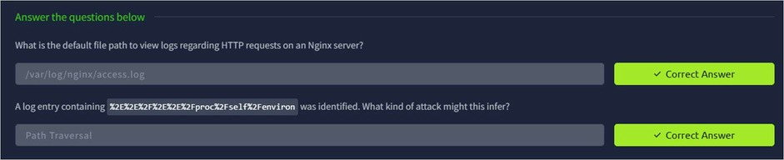
TASK 5 – Automated vs Manual Analysis
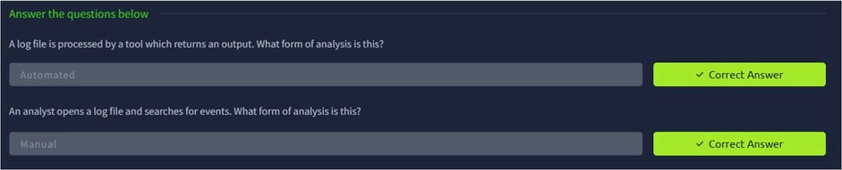
TASK 6 – Log Analysis Tools:Command Line
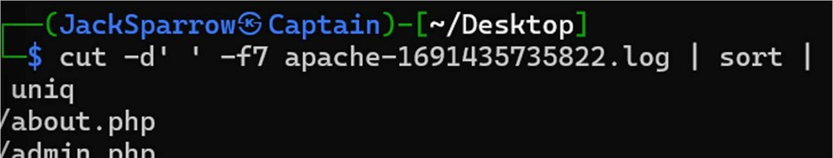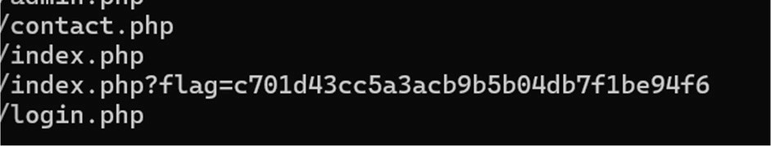
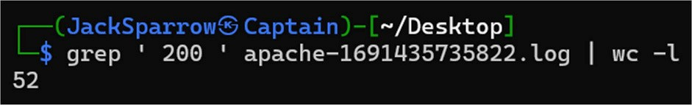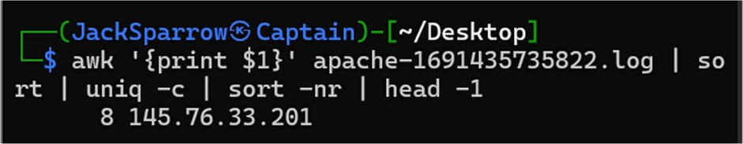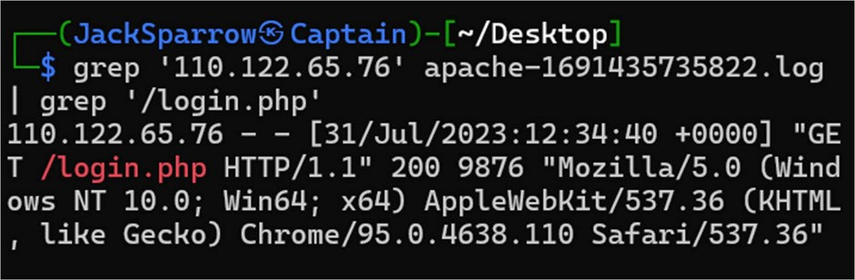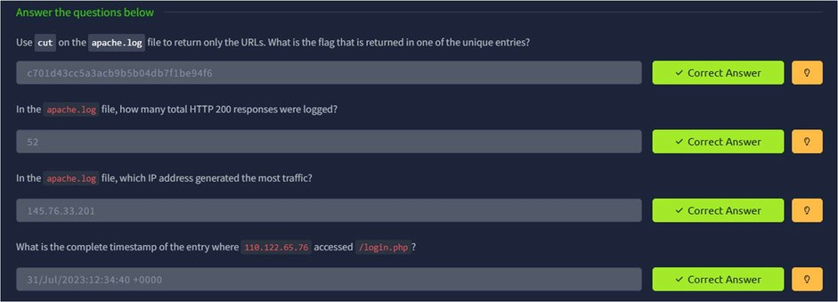
TASK 7 – Log Analysis Tools : Regular Expressions
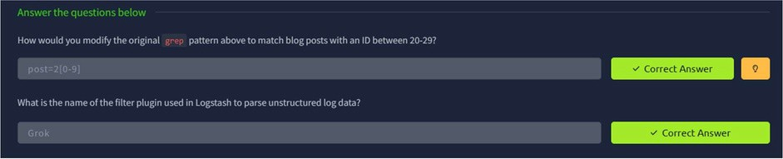
TASK 8 – Log Analysis Tools : CyberChef
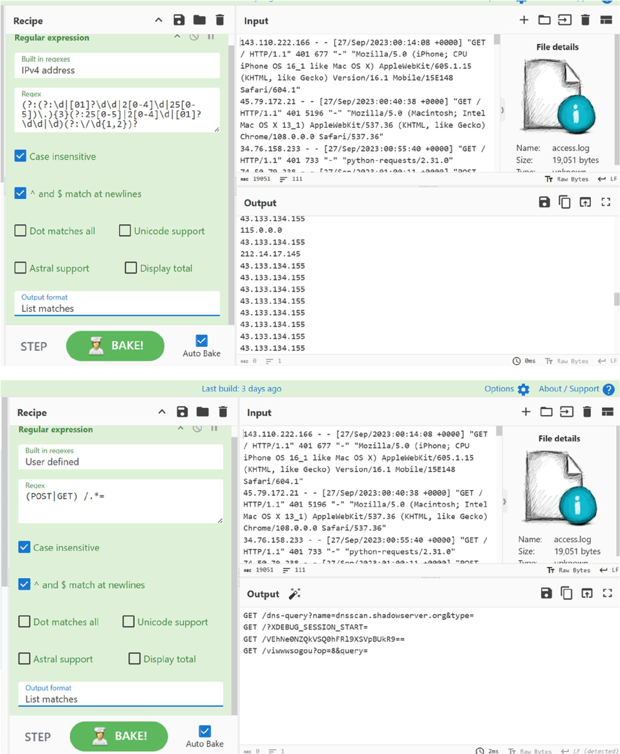
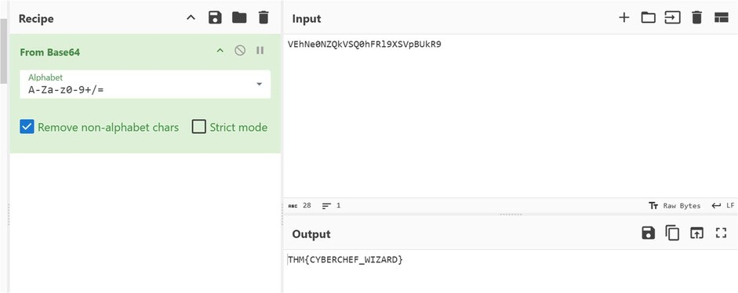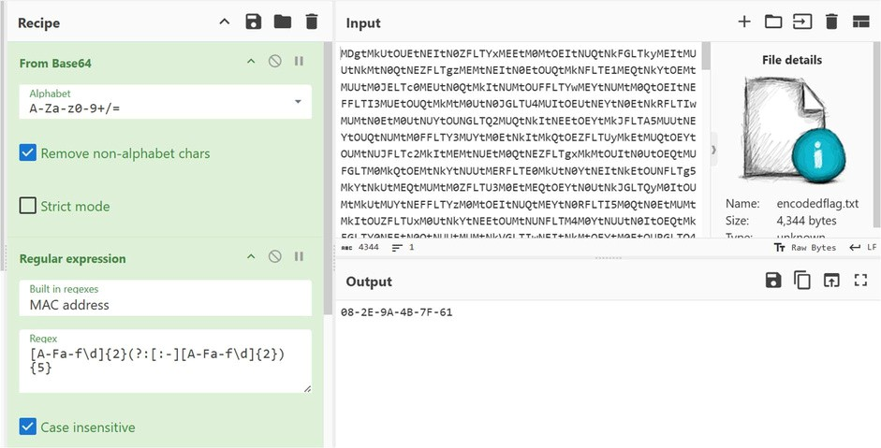
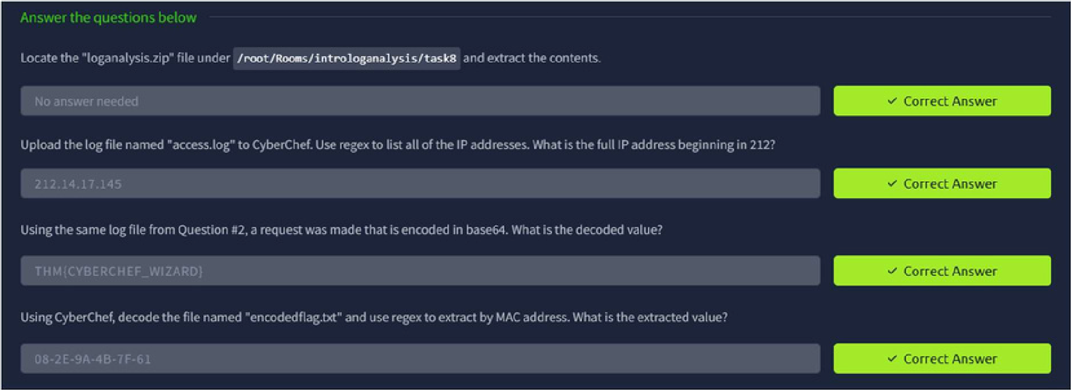
TASK 9 – Log Analysis Tools : Yara and Sigma
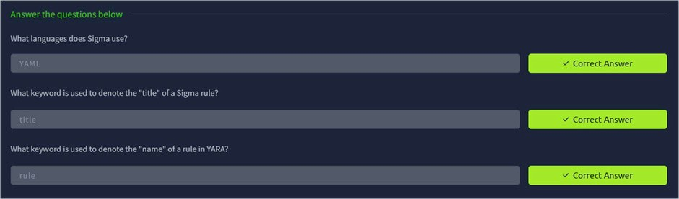
TASK 10 - Conclusion

Result:
Thus the TryHackMe room “Intro to Log Analysis” was completed successfully.

